7.1.9 Editors - 3D View - Header - Mesh - Edit mode - Mesh menu
Detailed Table of content 2
Edit Mode - Mesh Menu 10
Transform 10
To Sphere 10
Shear 11
Bend 12
Push/Pull 12
Warp 13
Randomize Transform 13
Shrink/Fatten 14
Skin Resize 15
Move Texture Space 15
Scale Texture Space 17
Set Dimensions 18
Mirror 18
Interactive Mirror 18
X Global, Y Global etc. 18
Mirror Vertex Group 19
Snap 20
Last Operator Snap 20
Single Operators 20
Duplicate 20
Extrude 21
Merge 24
Split 25
Separate 26
Convex Hull 27
Symmetrize 28
Snap to Symmetry 28
Smart Delete 29
Normals 29
Recalculate Outside 29
Recalculate Inside 30
Flip 30
Set from Faces 30
Rotate 30
Point Normals to Target 30
Merge 31
Split 31
Average 31
Copy Vectors 32
Paste Vectors 32
Smoothen Vectors 32
Reset Vectors 32
Select by Face Strength 32
Set Face Strength 32
Shading 32
Weights 33
Sort Elements 36
Subdivide 37
Show / Hide 38
Show Hidden 38
Hide Selected 38
Hide Unselected 38
Cleanup 39
Delete Loose 39
Decimate Geometry 39
Degenerate Dissolve 40
Make Planar Faces 40
Split Non-Planar Faces 40
Split Concave Faces 41
Merge by Distance 41
Fill Holes 41
Delete 41
Dissolve 42
Dissolve Vertices 43
Dissolve Edges 43
Dissolve Faces 43
Limited Dissolve 44
Edge Collapse 44
Mesh Select Mode 44

Detailed Table of content
Detailed Table of Content
Detailed Table of content 2
Edit Mode - Mesh Menu 10
Transform 10
To Sphere 10
Usage 10
Last Operator To Sphere Panel 11
Factor 11
Proportional editing 11
Proportional Falloff 11
Proportional Size 11
Connected 11
Projected(2D) 11
Shear 11
Last Operator Shear 11
Offset 11
Shear Axis 11
Axis 11
Axis Ortho 12
Orientation 12
Proportional editing 12
Proportional Falloff 12
Proportional Size 12
Connected 12
Projected(2D) 12
Bend 12
Push/Pull 12
Last Operator Push/Pull 12
Factor 12
Proportional editing 12
Proportional Falloff 13
Proportional Size 13
Connected 13
Projected(2D) 13
Warp 13
Last operator Warp 13
Warp Angle 13
Offset Angle 13
Min 13
Max 13
Randomize Transform 13
Last Operator Randomize Transform 13
Amount 13
Uniform 13
Normal 14
Random Seed 14
Shrink/Fatten 14
Last Operator Shrink/Fatten 14
Offset 14
Offset Even 14
Proportional editing 14
Proportional Falloff 14
Proportional Size 14
Connected 14
Projected(2D) 14
Skin Resize 15
Last Operator Skin Resize 15
Vector 15
Scale X, Y, Z 15
Orientation 15
Proportional editing 15
Proportional Falloff 15
Proportional Size 15
Connected 15
Projected(2D) 15
Move Texture Space 15
Last Operator Translate 16
Move X, Y Z 16
Orientation 16
Proportional editing 16
Proportional Falloff 16
Proportional Size 16
Connected 16
Projected(2D) 16
Scale Texture Space 17
Last Operator Resize Texture 17
Move X, Y Z 17
Orientation 17
Proportional editing 17
Proportional Falloff 17
Proportional Size 17
Connected 17
Projected(2D) 18
Set Dimensions 18
Last Operator Set Dimensions 18
New Dimensions 18
Mirror 18
Interactive Mirror 18
X Global, Y Global etc. 18
Last Operator Mirror 18
Orientation 19
Constraint Axis 19
Proportional editing 19
Proportional Falloff 19
Proportional Size 19
Connected 19
Projected(2D) 19
Mirror Vertex Group 19
Last Operator Mirror Vertex Group 19
Mirror Weights 19
Flip Group Names 19
All Groups 20
Topology Mirror 20
Snap 20
Last Operator Snap 20
Offset 20
Single Operators 20
Duplicate 20
Last Operator Duplicate 20
Mode 20
Move X, Y, Z 20
Orientation 20
Constraint Axis 20
Proportional editing 21
Proportional Falloff 21
Proportional Size 21
Connected 21
Projected(2D) 21
Extrude 21
Extrude Edges 21
Last Operator Extrude Only Edges and Move 21
Flip Normals 21
Move X Y Z 21
Orientation 21
Constraint Axis 22
Proportional editing 22
Proportional Falloff 22
Proportional Size 22
Connected 22
Projected(2D) 22
Extrude Vertices 22
Last Operator Extrude Only Vertices and Move 22
Move X Y Z 22
Orientation 22
Constraint Axis 22
Proportional editing 22
Proportional Falloff 22
Proportional Size 22
Connected 23
Projected(2D) 23
Dupli Extrude / Dupli Extrude Rotate 23
Dupli Extrude - with selected Faces 23
Dupli Extrude - with selected Vertices 23
Extrude Repeat 23
Last Operator Extrude Repeat 24
Steps 24
Spin 24
Last Operator Spin 24
Steps 24
Use Duplicates 24
Angle 24
Auto Merge 24
Flip Normals 24
Center X / Y / Z 24
Axis 24
Merge 24
At Center, At Cursor, Collapse 25
Last Operator Merge 25
Type 25
UV's 25
By Distance 25
Last Operator Merge by Distance 25
Merge Distance 25
Split 25
Selection 25
Faces by Edges / Faces by Edges by Vertices 25
Last Operator Edge Split 25
Type 25
Separate 26
Selection 26
By Material 26
By Loose Parts 26
Knife Project 26
Last Operator Knife Project 26
Cut through 26
Convex Hull 27
Last Operator Convex Hull 27
Delete Unused 27
Use existing Faces 27
Make Holes 27
Join Triangles 27
Max Face Angle 27
Max Shape Angle 27
Compare UV's 27
Compare Vcols 27
Compare Seam 27
Compare Sharp 27
Compare Materials 28
Symmetrize 28
Last Operator Symmetrize 28
Direction 28
Threshold 28
Snap to Symmetry 28
Last Operator Snap to Symmetry 28
Direction 28
Threshold 28
Factor 28
Center 28
Smart Delete 29
Normals 29
Recalculate Outside 29
Last Operator Recalc Outside 29
Inside 29
Recalculate Inside 30
Flip 30
Set from Faces 30
Rotate 30
Last Operator Rotate Normals 30
Angle 30
Axis 30
Orientation 30
Constraint Axis 30
Point Normals to Target 30
Last Operator Point Normals to Target 31
Invert 31
Align 31
Target 31
Spherize 31
Merge 31
Split 31
Average 31
Custom Normal 31
Face Area 31
Corner Angle 31
Last Operator Average Normals 31
Weigh 31
Threshold 32
Copy Vectors 32
Paste Vectors 32
Last Operator Normals Vector Tools 32
Absolute Coordinates 32
Smoothen Vectors 32
Last Operator Smooth Normals Vectors 32
Factor 32
Reset Vectors 32
Select by Face Strength 32
Set Face Strength 32
Shading 32
Weights 33
Normalize All 33
Last Operator Normalize all 33
Subset 33
Lock Active 34
Normalize 34
Mirror 34
Last Operator Mirror Vertex Group 34
Mirror Weights 34
Flip Group Names 34
All Groups 34
Topology Mirror 34
Invert 34
Last Operator Invert Vertex Group 34
Subset 34
Add Weights 34
Remove Weights 34
Clean 34
Last Operator Clean Vertex Group 35
Subset 35
Limit 35
Keep Single 35
Quantize 35
Last Operator Quantize 35
Subset 35
Steps 35
Levels 35
Last Operator Vertex Group Levels 35
Subset 35
Offset 35
Gain 35
Smooth 35
Last Operator Smooth Vertex Weights 35
Subset 35
Factor 35
Iterations 36
Expand/Contract 36
Limit Total 36
Last Operator Limit Number of Weights per Vertex 36
Subset 36
Limit 36
Fix Deforms 36
Last Operator Fix Deforms 36
Distance 36
Strength 36
Change Sensitivity 36
Sort Elements 36
View Z Axis 37
View Y Axis 37
Cursor Distance 37
Material 37
Selected 37
Randomize 37
Reverse 37
Last Operator Sort Mesh Elements 37
Type 37
Vertices, Edges or Faces 37
Reverse Checkbox 37
Seed Edit box (Randomize only) 37
Subdivide 37
Last Operator Subdivision Set 38
Level 38
Relative 38
Show / Hide 38
Show Hidden 38
Hide Selected 38
Hide Unselected 38
Last Operator Reveal Hidden / Hide Selected 38
Select 38
Cleanup 39
Delete Loose 39
Last Operator Delete Loose 39
Vertices 39
Edges 39
Faces 39
Decimate Geometry 39
Last Operator Decimate Geometry 39
Ratio 39
Vertex Group 39
Weight 40
Invert 40
Symmetry 40
Degenerate Dissolve 40
Make Planar Faces 40
Last Operator Make Planar Faces 40
Factor 40
Iterations 40
Split Non-Planar Faces 40
Last Operator Split Non-Planar Faces 41
Max Angle 41
Split Concave Faces 41
Merge by Distance 41
Last Operator Merge by Distance 41
Merge Distance 41
Unselected 41
Fill Holes 41
Last Operator Fill Holes 41
Sides 41
Delete 41
Vertices 42
Edges 42
Faces 42
Only Edges and Faces 42
Only Faces 42
Edge Loops 42
Last Operator Delete Edge Loop 42
Face Split 42
Dissolve 42
Dissolve Vertices 43
Last Operator Dissolve Vertices 43
Face Split 43
Tear Boundary 43
Dissolve Edges 43
Last Operator Dissolve Edges 43
Dissolve Verts 43
Face Split 43
Dissolve Faces 43
Last Operator Dissolve Faces 43
Dissolve Verts 43
Limited Dissolve 44
Last Operator Limited Dissolve 44
Max Angle 44
All Boundaries 44
Delimit 44
Edge Collapse 44
Mesh Select Mode 44

Edit Mode - Mesh Menu

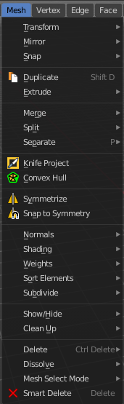
The Mesh Menu in Edit Mode contains the tools to manipulate the mesh geometry in Edit mode. It just exists for Mesh Objects.

Lots of functionality that could also belong here can also be found in the Tool Shelf. The difference is that the tools in the tool shelf are easier to access. And so it contains the most used tools for the daily work. While the Mesh menu contains the not so often used tools. Or tools where you use the hotkey anyway. Delete for example.

Transform
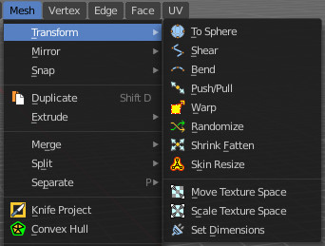

To Sphere
Shapes a selection of objects into the shape of a sphere. The calculation happens with the object origins.
In Object mode this tools requires to have more than one object selected.

Usage

Select the vertices, activate the tool, then drag the mouse in the 3D viewport. In the header you will read the current factor then. Which tells you how close you are towards the sphere shape.



Last Operator To Sphere Panel

Factor
The factor to transform the selection into a shape form.


Proportional editing
Enables proportional editing. Activating proportional editing reveals further settings.

Proportional Falloff
Adjust the falloff methods.

Proportional Size
See and adjust the falloff radius.

Connected
The proportional falloff gets calculated for connected parts only.

Projected(2D)
The proportional falloff gets calculated in the screen space. Depth doesn't play a role. When it's in the radius, then it gets calculated.

Shear
Shear shears the selection.


Last Operator Shear

Offset
Adjust an offset.

Shear Axis
The shear tool works along a imaginary 2d plane. The shear axis controls if the items are sheared along the x or the y axes of this plane. This is the plane along which the transformation happens. You can shear along the x or the y axis of this plane.
To make things even more complicated, the orientation of this imaginary plane is defined by the Axis and Axis Ortho items below.

Axis
Defines one axis of the imaginary shear axis plane.


Axis Ortho
Defines the other axis of the imaginary shear axis plane.

Orientation
Choose the orientation for the shear action.

Proportional editing
Enables proportional editing. Activating proportional editing reveals further settings.

Proportional Falloff
Adjust the falloff methods.

Proportional Size
See and adjust the falloff radius.

Connected
The proportional falloff gets calculated for connected parts only.

Projected(2D)
The proportional falloff gets calculated in the screen space. Depth doesn't play a role. When it's in the radius, then it gets calculated.

Bend
Bends the selection.

Push/Pull
It pushes or pulls the object positions relative to the center of the selection.
In Object mode this tool requires to have more than one object selected.


Last Operator Push/Pull

Factor
Adjust the strength of influence of the tool.

Proportional editing
Enables proportional editing. Activating proportional editing reveals further settings.

Proportional Falloff
Adjust the falloff methods.

Proportional Size
See and adjust the falloff radius.

Connected
The proportional falloff gets calculated for connected parts only.

Projected(2D)
The proportional falloff gets calculated in the screen space. Depth doesn't play a role. When it's in the radius, then it gets calculated.


Warp
Warps a mesh selection between two defined points.

Last operator Warp

Warp Angle
The strength of the warp effect

Offset Angle
An offset angle to bend side wards.


Min
The start point.

Max
The end point.

Randomize Transform
This tool allows randomizes the positions of the selected vertices.


Last Operator Randomize Transform

Amount
Adjust the amount.

Uniform
The uniform offset distance.

Normal
Align the offset direction to the normals.

Random Seed
The seed value for randomization.

Shrink/Fatten
Shrink/Fatten scales the selected geometry along its normals. Transform orientation and Pivot point gets ignored.
A positive value pushes the vertices outwards. A negative value pushes the vertices inwards.


Last Operator Shrink/Fatten
The Last Operator Shrink/Fatten panel gives you tools to adjust the Shrink/Fatten operation. Here you have numeric input for the strength and a few more options.

Offset
Offset is the strength of the offset for Shrink/Fatten.

Offset Even
Offset Even scales the selection to give more thickness in even areas.

Proportional editing
Enables proportional editing. Activating proportional editing reveals further settings.

Proportional Falloff
Adjust the falloff methods.

Proportional Size
See and adjust the falloff radius.

Connected
The proportional falloff gets calculated for connected parts only.

Projected(2D)
The proportional falloff gets calculated in the screen space. Depth doesn't play a role. When it's in the radius, then it gets calculated.

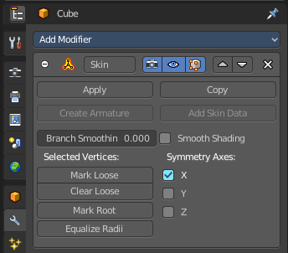
Skin Resize
This tool requires to have a skin modifier at the mesh. It scales the thickness of the skin.
While the operation you will see in the header the strength value for the skin.

Last Operator Skin Resize

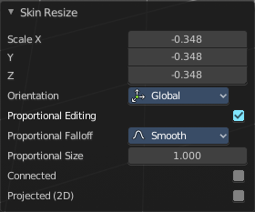
Vector
Adjust the position values for the three values.

Scale X, Y, Z
Limit the position relative to the source object.

Orientation
Orientation is a drop-down box choose the type of orientation for the mirroring action.

Proportional editing
Enables proportional editing. Activating proportional editing reveals further settings.

Proportional Falloff
Adjust the falloff methods.

Proportional Size
See and adjust the falloff radius.

Connected
The proportional falloff gets calculated for connected parts only.

Projected(2D)
The proportional falloff gets calculated in the screen space. Depth doesn't play a role. When it's in the radius, then it gets calculated.


Move Texture Space
This tool relies at the move tool. With the difference that it moves the texture space instead of the object. It has also a very special use case, and just works with a material with a Texture Coordinate / Generated node. And requires to have the shading at Material or Rendered to see a result in the viewport.
In the viewport you will see the UV cage in black color. In the header you will see the values for the current position of the UV cage.
Note that once done and applied, there is no way to reset the UV cage back to zero. When you repeat the operation, then the values will start at 0 again. Even when the UV cage is already offset.



Last Operator Translate

Move X, Y Z
Limit the position relative to the source object.

Orientation
Orientation is a drop-down box choose the type of orientation for the mirroring action.

Proportional editing
Enables proportional editing. Activating proportional editing reveals further settings.

Proportional Falloff
Adjust the falloff methods.

Proportional Size
See and adjust the falloff radius.

Connected
The proportional falloff gets calculated for connected parts only.

Projected(2D)
The proportional falloff gets calculated in the screen space. Depth doesn't play a role. When it's in the radius, then it gets calculated.


Scale Texture Space
This tool relies at the scale tool. With the difference that it scales the texture space instead of the object. It has also a very special use case, and just works with a material with a Texture Coordinate / Generated node. And requires to have the shading at Material or Rendered to see a result in the viewport.
In the viewport you will see the UV cage in black color. In the header you will see the values for the current position of the UV cage.
Note that once done and applied, there is no way to reset the UV cage back to zero. When you repeat the operation, then the values will start at 0 again. Even when the UV cage is already offset.



Last Operator Resize Texture

Move X, Y Z
Limit the position relative to the source object.

Orientation
Orientation is a drop-down box choose the type of orientation for the mirroring action.

Proportional editing
Enables proportional editing. Activating proportional editing reveals further settings.

Proportional Falloff
Adjust the falloff methods.

Proportional Size
See and adjust the falloff radius.

Connected
The proportional falloff gets calculated for connected parts only.

Projected(2D)
The proportional falloff gets calculated in the screen space. Depth doesn't play a role. When it's in the radius, then it gets calculated.


Set Dimensions
Edit Mode Only!
Normally all scale operations in Bforartists are relative to the current selection and dimensions. And you always start with a relative value of 1.
Set dimensions allows to scale mesh selections in absolute world values. No matter how the initial values are. The new values gets set in the Last Operator.
Set dimensions is an add-on. You can turn it off in the add-ons section of the user preferences when you want.

Last Operator Set Dimensions


New Dimensions
When you activate the tool then you will see the world coordinates of the selection. Change the values to other world coordinates.

Mirror


Mirror mirrors the selected geometry along the defined axis.

Interactive Mirror
Mirror by hotkeys. You activate the tool, type in x for x global for example, or x x for x local. And the selection gets mirrored

X Global, Y Global etc.
Mirrors the selection around the chosen axis.

Last Operator Mirror

The Last Operator Mirror panel gives you tools to adjust the mirror action.

Orientation
Orientation is a drop-down box choose the type of orientation for the mirroring action.

Constraint Axis
Constraint Axis gives you again the possibility to define the mirror axis. You can choose more than one axis here.

Proportional editing
Enables proportional editing. Activating proportional editing reveals further settings.

Proportional Falloff
Adjust the falloff methods.

Proportional Size
See and adjust the falloff radius.

Connected
The proportional falloff gets calculated for connected parts only.

Projected(2D)
The proportional falloff gets calculated in the screen space. Depth doesn't play a role. When it's in the radius, then it gets calculated.

Mirror Vertex Group
This tool requires to have a vertex group assigned. It mirrors the selected vertex group.
This tool works only with a perfectly symmetrical mesh along the local X axis. Vertices that have no corresponding vertex on the other side will not be affected.

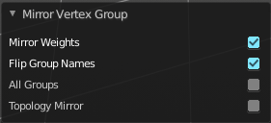
Last Operator Mirror Vertex Group

Mirror Weights
Mirrors the Weight Painting informations from the symmetrical counterpart. When both are selected it will become a group and weight information exchange. If only one is selected, then the information from the unselected vertice will go to the selected vertice.

Flip Group Names
Flip selected group names. This works with vertex groups with symmetrical name conventions. Like .L , .R, right, left.

All Groups
Pass information to all groups instead of the active one.

Topology Mirror
Use topology based mirroring.

Snap

Choose several methods to snap one element to another. The menu items should be self explaining.

Last Operator Snap

Some snap operations shows a last operation panel, some not.

Offset
If the selection should snap as a whole, or if each individual element of the selection should snap.

Single Operators

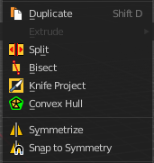
Duplicate
Duplicates the current selection.
When you duplicate a selection, then it sticks to the mouse until you left click. And moves around. A right click repositions the duplicated geometry at its original location.

Last Operator Duplicate

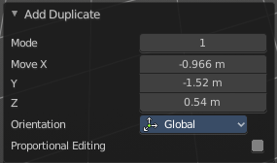
Mode
Not to find out. No tool tip, no entry in the Blender manual. Good Job Blender Developers.

Move X, Y, Z
Adjust the position.

Orientation
Orientation is a drop-down box choose the type of orientation for the mirroring action.

Constraint Axis
Constraint Axis gives you again the possibility to define the mirror axis. You can choose more than one axis here.

Proportional editing
Enables proportional editing. Activating proportional editing reveals further settings.

Proportional Falloff
Adjust the falloff methods.

Proportional Size
See and adjust the falloff radius.

Connected
The proportional falloff gets calculated for connected parts only.

Projected(2D)
The proportional falloff gets calculated in the screen space. Depth doesn't play a role. When it's in the radius, then it gets calculated.

Extrude
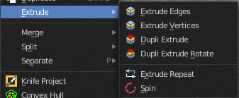
Extrude is a sub menu with several extrude methods. The contend is dependent of the mesh select mode.

Note that the tool shelf also contains extrude functionality.
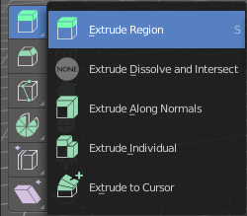

Extrude Edges
Extrudes out the selected edges by moving the mouse.

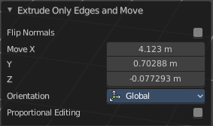
Last Operator Extrude Only Edges and Move

Flip Normals
Flip the normals at the involved faces.

Move X Y Z
The coordinates for the extruded geometry.

Orientation
Choose the type of orientation, in which coordinate system the action should happen.

Constraint Axis

Proportional editing
Enables proportional editing. Activating proportional editing reveals further settings.

Proportional Falloff
Adjust the falloff methods.

Proportional Size
See and adjust the falloff radius.

Connected
The proportional falloff gets calculated for connected parts only.

Projected(2D)
The proportional falloff gets calculated in the screen space. Depth doesn't play a role. When it's in the radius, then it gets calculated.

Extrude Vertices
Extrudes out the selected vertices by moving the mouse.

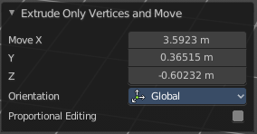
Last Operator Extrude Only Vertices and Move

Move X Y Z
The coordinates for the extruded geometry.

Orientation
Choose the type of orientation, in which coordinate system the action should happen.

Constraint Axis

Proportional editing
Enables proportional editing. Activating proportional editing reveals further settings.

Proportional Falloff
Adjust the falloff methods.

Proportional Size
See and adjust the falloff radius.

Connected
The proportional falloff gets calculated for connected parts only.

Projected(2D)
The proportional falloff gets calculated in the screen space. Depth doesn't play a role. When it's in the radius, then it gets calculated.

Dupli Extrude / Dupli Extrude Rotate
Dupli Extrude is a two trick tool. With faces selected it creates a rotated copy of the geometry. With edges or vertices selected it extrudes to the mouse position. That's why it is a good idea to use this tool with a hotkey. But note that we have currently no hotkey assigned to this legacy functionality.
Dupli Extrude Rotate behaves the same than Dupli Extrude, but rotates the source geometry too.

Dupli Extrude - with selected Faces
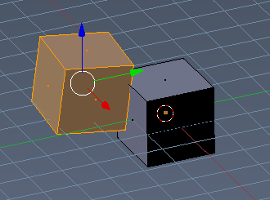
Dupli Extrude with selected faces creates a copy of the selection and rotates it slightly.

Dupli Extrude - with selected Vertices
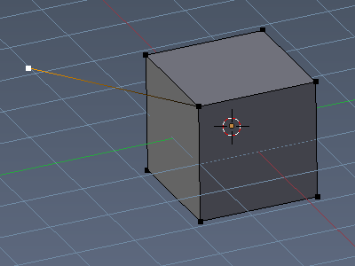
Dupli Extrude with selected vertices extrudes the vertice to the mouse position.

Extrude Repeat
All modes. Extrudes into the Z depth of the viewport, and repeats the extrusion by the adjusted amount. You have to adjust the extrusion afterwards.

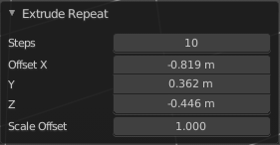
Last Operator Extrude Repeat

Steps
How much repetitions.
Offset X / Y / Z
The offset in the x y and z direction.
Scale Offset
The scale factor of the extruded element.

Spin
All modes. Extrudes in a curve form.

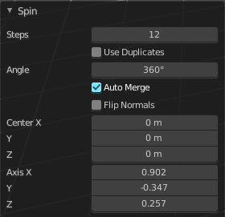
Last Operator Spin

Steps
How much segments.

Use Duplicates
Creates not connected geometry. In Vertex mode single vertices for example. Auto Merge and Flip Normals will not be available with duplicates.

Angle
The angle to extrude.

Auto Merge
Merge first and last element when the extrude is a full circle.

Flip Normals
Flip the normals of the extruded geometry.

Center X / Y / Z
The center point of the spin circle.

Axis
Axis in global View space. The values goes from -1 to 1.

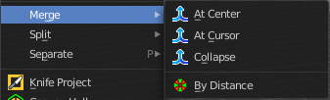
Merge
Merges the geometry.

At Center, At Cursor, Collapse
Merges the geometry with the given methods.

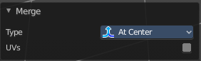
Last Operator Merge

Type
Choose the merge method again.

UV's
Move the UV's according to the merge.

By Distance
Merge the vertices by their distance to each other. This tool is meant to remove double vertices at the same location.

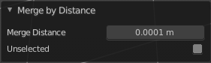
Last Operator Merge by Distance

Merge Distance
Adjust the distance below which the vertices gets merged.
Merge selected vertices to unselected vertices.

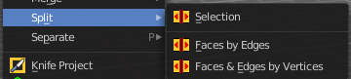
Split

Selection
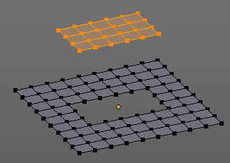
Split splits the edges between the selected vertices. It creates two edges out of one. And splits the edge by that.
The mode doesn't matter. There will always the edges be splitted.

Faces by Edges / Faces by Edges by Vertices
Splits selected edges so that each neighbor face gets its own copy. You have two methods here.

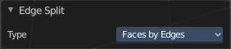
Last Operator Edge Split

Type
Choose the method again.

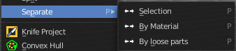
Separate
Separate separates the selected geometry, and creates a new object. The geometry becomes uneditable, since it is now a new object. You will have to leave the Edit mode, select the new object, and re-enter Edit mode when you want to edit it.

Selection
Selection separates the current selection.

By Material
By Material separates all geometry that has the same material than the current selection.

By Loose Parts
By Loose parts separates all geometry that is connected by edges to the current selection.

Knife Project
Knife Project uses an object as a knife to cut edges into a mesh.
Usage: Create a cube. Create a circle. Rotate the circle by 90 degrees, and move it in front of the cube so that it does not overlap the cube. Now go into front view. Select circle, hold down shift, select Cube. Enter Edit Mode. Click the Knife Project tool.
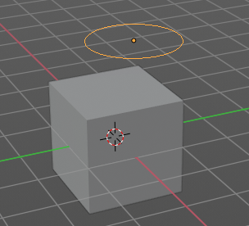 | 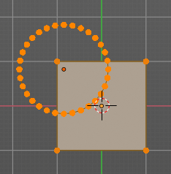 | 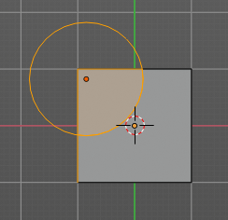 | 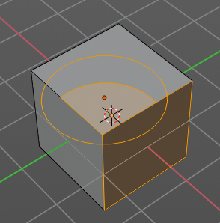

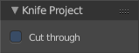
Last Operator Knife Project

Cut through
The cut goes through the whole object when the Cut through checkbox is ticked.
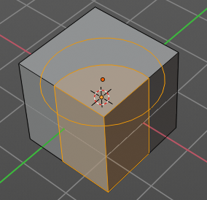

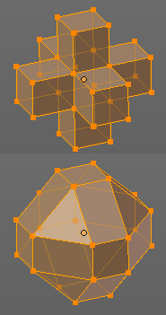
Convex Hull
Creates a convex hull around the outside of selected vertices. The old faces and inlaying vertices gets removed.

Last Operator Convex Hull

Delete Unused
Removes vertices that are not part of the convex geometry.

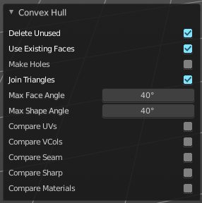
Use existing Faces
Use existing input faces that lies on the hull where possible. This option allows to have N-Gons in the convex hull.

Make Holes
Deletes edges and faces in the hull that were part of the input. This allows to delete faces between the existing mesh and the convex hull.

Join Triangles
Joins adjacent triangles into quads.

Max Face Angle
Max Face Angle belongs to the Join Triangles setting. Set the maximum face angle.

Max Shape Angle
Max Face Angle belongs to the Join Triangles setting. Set the maximum shape angle.

Compare UV's
Takes existing UV patches for the calculation into account.

Compare Vcols
Takes existing Vertex colors for the calculation into account.

Compare Seam
Takes existing seams for the calculation into account.

Compare Sharp
Takes existing sharp edges for the calculation into account.

Compare Materials
Takes existing materials for the calculation into account.

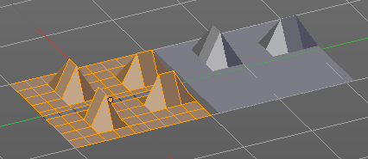
Symmetrize
The Symmetrize tool mirrors the selected geometry symmetrical along a world axis.

Last Operator Symmetrize

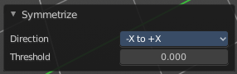

Direction
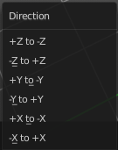
Direction is a drop down box define the mirroring direction.

Threshold
Adjust a distance after which the mirroring should happen, relative to the mirror axis. 0 means it mirrors the geometry directly at the axis.

Snap to Symmetry
Tries to snap the selected vertices symmetrical along the chosen world orientation.

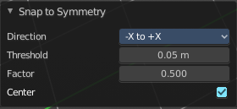
Last Operator Snap to Symmetry

Direction
The calculation direction.

Threshold
The threshold defines the radius in which matching vertices gets located. When you get a warning that snapping failed try increasing the threshold value.

Factor
The snapping factor. Blend mirrored locations from one side to the other. 0.5 is blending both sides equal.

Center
Snap vertices in the center axis to zero.

Smart Delete
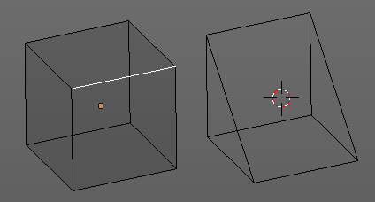
Smart delete deletes what is selected in an intelligent way. When you for example delete an edge then the edge gets deleted. But it also deletes the vertices connected to this edge. It performs a Dissolve operation under the hood.
There is also a Delete and Dissolve menu in the Mesh menu, choose different methods for deleting if required.
Smart delete is an add-on. And can be deactivated if desired.

Normals

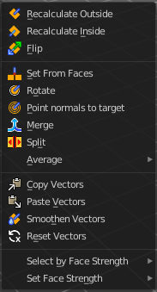
This menu contains functionality about dealing with normals. Normals influences the shading and the direction of a face. They can point inwards or outwards. And edges can be split. So that two adjacent faces have a sharp edge.

You can activate the display of normals in the Overlays panel in Edit mode.

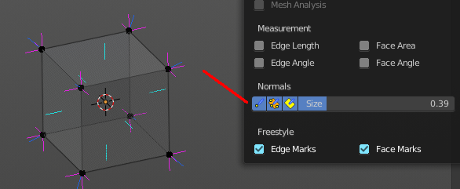

Recalculate Outside
Recalculates the normals of the selected geometry so that everything points outwards.

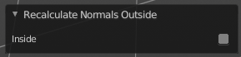
Last Operator Recalc Outside

Inside
Inside recalculates the normals of the selected geometry so that everything points inwards.

Recalculate Inside
Recalculates the normals of the selected geometry so that everything points inwards.

Flip
Flips the direction of the normals of the selected geometry.

Set from Faces
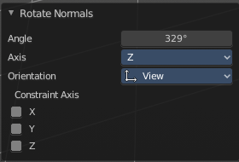
Sets the vertex normals from the selected faces. This tool requires to have Auto smooth activated!

Rotate
Rotate the normals of the selected vertices manually.

Last Operator Rotate Normals

Angle
The angle of the selected normal(s).

Axis
The axis to rotate around.

Orientation
Choose the type of orientation, in which coordinate system the action should happen.

Constraint Axis
Constraint specific axis.

Point Normals to Target
All vertex normals will point to a specific target. This target can be chosen from hotkeys. They show in the header.

Pressing R for Reset will reset the normals to where they were before the operation.

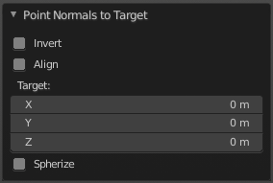
Last Operator Point Normals to Target

Invert
The normal directions are reversed from what is specified.

Align
All normals will point in the same direction.

Target
The target position.

Spherize
Each normal will be interpolated between its original value and the direction to the target.

Merge
Merge all of the normals at selected vertices, making one average normal for all of the faces.

Split
Split the normals at all selected vertices so that there are separate normals for each face, pointing in the same direction as those faces.

Average
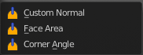
Average all of the normals in each fan of faces between sharp edges at a vertex.

Custom Normal
Take the average of vertices normals.

Face Area
Set all vertices normals by face area.

Corner Angle
Set all vertices by corner angle.

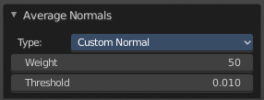
Last Operator Average Normals
Type
Choose the average type again.

Weigh
Just for custom normals method. Weight applied by face.

Threshold
Just for custom normals method. Threshold value for different weights to be considered as equal.

Copy Vectors
Copies the normals of a single selected vertice.

Paste Vectors
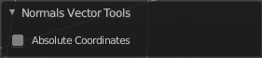
Pastes the normals from a formerly copied selected vertice to the currently selected vertice.

Last Operator Normals Vector Tools

Absolute Coordinates
When you paste normals then they get pasted relative to the current orientation of the selected vertice. With absolute coordinates the normals gets pasted in world coordinates.

Smoothen Vectors
Smooth custom normals towards the adjacent vertex normals.

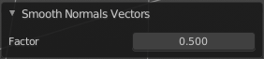
Last Operator Smooth Normals Vectors

Factor
Adjust how strong the smoothen should be.

Reset Vectors
Resets the normal of the selected element(s).

Select by Face Strength
Face strength gets used by the Weighted Normals modifier. See Face Influence checkbox.
Select faces with either weak or medium or strong face strength.

Set Face Strength
Face strength gets used by the Weighted Normals modifier. See Face Influence checkbox.
Set selected faces to either a weak, a medium or a strong face strength.

Shading
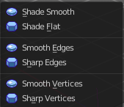
Sets the shading of the selected elements to either smooth or flat.

Shading is under the hood a normals operation.

Weights

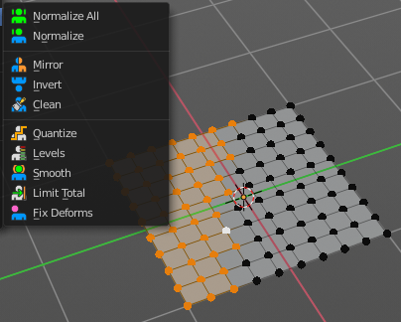
The Weights menu contains Weight tools. Those tools are meant to modify the weight mapping. At characters for example. The Weight Tools requires Vertex Groups to work with. Such Vertex groups gets created when you do weight painting at a character for example. Here is defined what bone is connected to what vertice.
In Edit Mode the weight mapping doesn't show. Here you work with the Vertex Groups.
In Weight paint mode the weight painting shows with colors. Here you usually paint the weighting.
This menu items also exists in Weight Paint mode.
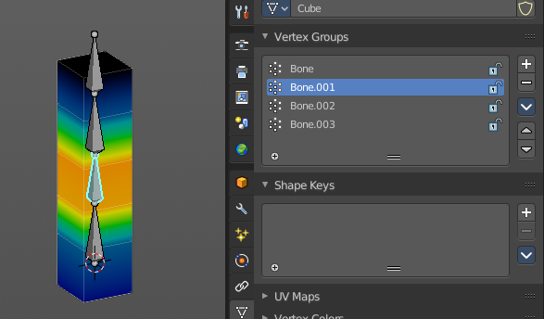

Normalize All
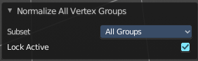
While weight painting it can happen that a vertice gets several weightings assigned. Normalize all normalizes the weight of all Vertex groups so that the values for the single vertices in the sum is 1.

Last Operator Normalize all

Subset
Subset is a drop-down menu choose the Subset method.

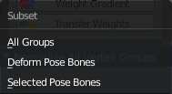
Lock Active
Keep the values of the active group while normalizing others.

Normalize
Normalize normalizes the weight of the current selected Vertex group so that the values for the single vertices in the sum is 1. Means when there is influence from other groups, then those values are kept, but the one for the current group gets lowered so that the sum is 1.
The Last Operator Normalize panel has no adjustable settings.

Mirror
Mirror Vertex Group mirrors Vertex Groups and flips weights and/or names. It only edits selected Vertices. It flips when both sides are selected. Otherwise it copies from Unselected.

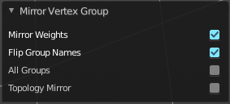
Last Operator Mirror Vertex Group

Mirror Weights
With Mirror Weights ticked it mirrors the weights.

Flip Group Names
With Flip Group Names ticked it flips the Group names.

All Groups
Mirrors all Vertex Groups

Topology Mirror
Uses topology based mirroring. This requires matching mirrored topology.

Invert
Invert inverts the weight painting for the selected vertex group.

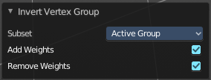
Last Operator Invert Vertex Group

Subset
Subset is a drop-down menu choose the Subset method.

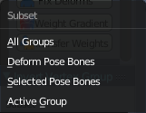
Add Weights
Add Vertices from Groups that have zero Weighting before inverting.

Remove Weights
Remove Vertices from Groups that have zero weight after inverting.

Clean
Removes Vertex group assignments that are not required from the active vertex group.

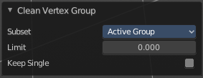
Last Operator Clean Vertex Group

Subset
Subset is a drop-down menu choose the Subset method.

Limit
Remove weights that are below or equal to the limit value.

Keep Single
Keep Vertices assigned to at least one vertex group when cleaning.

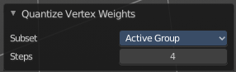
Quantize
Quantize quantizes the weight paint values. It starts with 4 steps. With a step of 1 you have a single vertex color, no matter how you have painted it before.

Last Operator Quantize

Subset
Subset is a drop-down menu choose the Subset method.

Steps
Here you adjust in how many steps the weight paint colors should be divided.

Levels
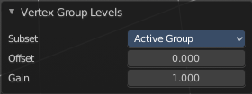
Adds some offset to the Weight paint, and multiplys it with some gain.

Last Operator Vertex Group Levels

Subset
Subset is a drop-down menu choose the Subset method.

Offset
Here you adjust the offset.

Gain
Here you adjust the gain.

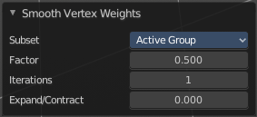
Smooth
Smooths the weight for selected vertices.

Last Operator Smooth Vertex Weights

Subset
Subset is a drop-down menu choose the Subset method.

Factor
Here you adjust the factor.

Iterations
Here you adjust how many iterations you use.

Expand/Contract
Expand or contract the weights.

Limit Total
Limit number of Weights per vertex. The lowest weights gets removed.
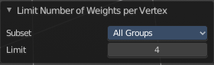
This is of interest when you have for example five bones associated with a vertice. But your game engine just allows four ...

Last Operator Limit Number of Weights per Vertex

Subset
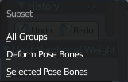
Subset is a drop-down menu choose the Subset method.

Limit
Here you adjust how many weights are allowed.

Fix Deforms
Modify the position of selected vertices by changing only their respective group weights.
This tool may operate slow at too many vertices.

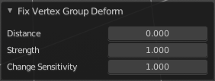
Last Operator Fix Deforms

Distance
Adjust the distance.

Strength
Adjust the strength.

Change Sensitivity
Adjust the sensitivity.

Sort Elements
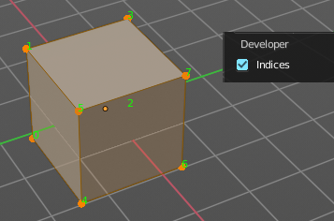
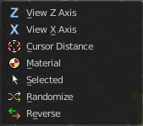
Sort Elements is a menu with different sorting methods. It allows you to reorder the mesh indices of the selected mesh elements by various methods.
The indices can be turned on in the Overlays menu in the Developer section.

View Z Axis
Sorts along the active view’s Z axis, from farthest to nearest. You can use Reverse if you want it the other way.

View Y Axis
Sorts along the active view’s Y axis, from farthest to nearest. You can use Reverse if you want it the other way.

Cursor Distance
Sorts from nearest to farthest away from the 3D cursor position.

Material
Faces only! Sorts faces by their lowest material index up to highest material index. Order of faces inside each of those material groups remains unchanged.

Note that the Reverse option only reverses the order of the materials. And the order of the faces inside them.

Selected
Moves all selected elements to the beginning without affecting their relative orders. Attention, this option will also affect unselected element indices!

Randomize
Randomizes the indices of selected elements. This option does not affect the unselected elements.

Reverse
Reverses the order of the selected elements.

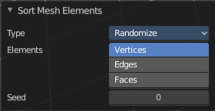
Last Operator Sort Mesh Elements
Sort Elements always brings up the same last operator. But with a small difference for Randomize and Reverse. Reverse has no checkbox. And Randomize has a Seed checkbox.

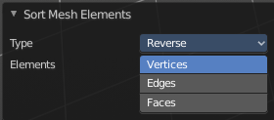
Type
This is a drop-down box choose the sort method again.

Vertices, Edges or Faces
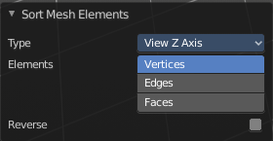
Adjust if the sort will affect the vertices, edges or faces.

Reverse Checkbox
Reverses the sorting.

Seed Edit box (Randomize only)
The seed option allows you to get another randomization – the same seed over the same mesh/set of selected elements will always give the same result!

Subdivide
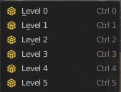
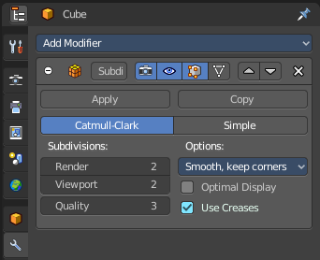
Subdivide is a menu where you can quickly add and change a subdivision surface modifier with a predefined resolution in a quick way. Especially when you use the hotkey for it. The subdivision surface modifier panel can then as usual be found in the Properties editor in the Modifier tab.

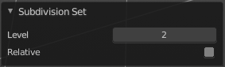
Last Operator Subdivision Set

Level
Set the level of subdivisions

Relative
Applies the sub surf level as an offset to the already existing sub surf level.

Show / Hide

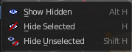
The Show/Hide menu is available for all object types and in all modes. It is usually in the object related menu to find. In Object mode it's the Object menu, for a curve object in edit mode it is the Curve menu. It always contains three menu items. Show Hidden, Hide Selected and Hide Unselected.

Show Hidden
Makes all hidden elements in the scene visible again.

Hide Selected
Hides the selected elements.

Hide Unselected
Hides the not selected elements. The selected elements stays visible.

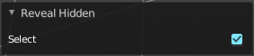
Last Operator Reveal Hidden / Hide Selected

Select
Define if the selected or the unselected elements gets hidden or revealed.

Cleanup

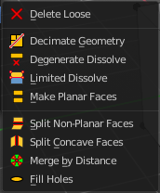
In the Cleanup menu you will find tools to clean up the current geometry.

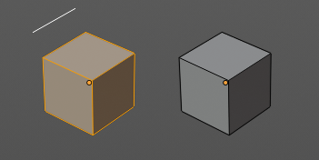
Delete Loose
Delete loose deletes not connected geometry. Vertices, Edges, and Faces. The tool starts with deleting Vertices and Edges. But you can tick Faces in the Last Operator too, and then it also removes not connected Faces.

Last Operator Delete Loose

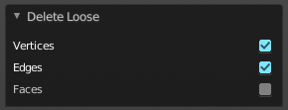
Vertices
Delete Vertices.

Edges
Delete Edges.

Faces
Delete Faces.

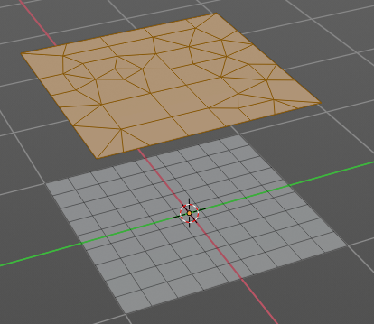
Decimate Geometry
Decimate Geometry decimates the currently selected geometry. It starts with a Ratio of 1. Which means no decimation. The lower the ratio the more decimation you will get. The Decimate Modifier works with Tris!

Last Operator Decimate Geometry

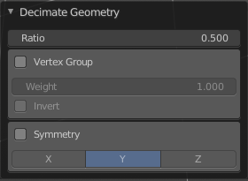
Ratio
Adjust the strength of decimation.

Vertex Group
Use active Vertex Group as an influence. You need to have a Vertex Group.

Weight
Adjust the Vertex Group Strength.

Invert
Invert Vertex Group Influence.

Symmetry
Make the decimation geometry symmetric along a chosen world axis.

Degenerate Dissolve
Removes zero size Faces and Edges.

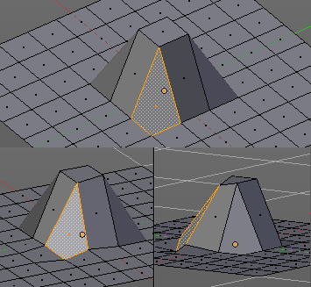
Make Planar Faces
Make Planar Faces tries to make the selected faces planar. Quads or N-Gons for example can have vertices that are not planar.

Last Operator Make Planar Faces

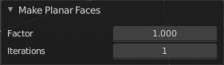
Factor
Here you adjust how strong the influence should be.

Iterations
Here you adjust how often it should repeat in the try to find a solution.

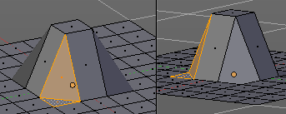
Split Non-Planar Faces
Split Non Planar Faces splits up non planar Quads and N-Gons to end in planar faces.

Last Operator Split Non-Planar Faces

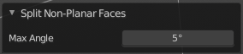
Max Angle
Limit the action to a maximum angle.

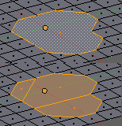
Split Concave Faces
Splits concave faces to make the geometry more stable. This tool is thought for N-Gons.

Merge by Distance
Merges vertices that are very close to each other. The merge happens at the center. When you need more control then you should use the Merge Vertices tool.

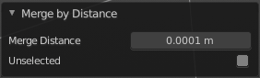
Last Operator Merge by Distance

Merge Distance
Adjust the distance in which the vertices gets merged.

Unselected
Merge selected vertices also with other unselected vertices.

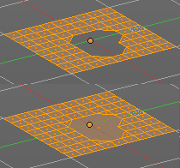
Fill Holes
Fill holes closes holes in the mesh geometry.
Fill holes can just calculate one face size at one time. So when you have several holes in the mesh, let's say one is a tri, and one is a quad, then you need to calculate twice.

Last Operator Fill Holes

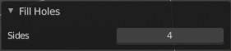
Sides
Define what face size will be filled.

Delete

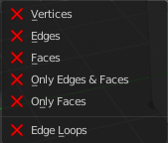
The smart delete add-on. usually does the delete job already fine. It deletes the selected element(s).

There are sometimes some situations where you need more control over what you want to delete. The tools for this can be found in the Delete menu.

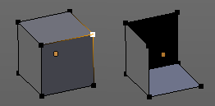
Vertices
Deletes the selected vertices, and all with it connected edges and faces.

Edges
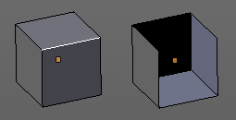
Deletes the selected edges and the connected faces.

Faces
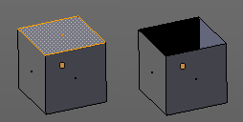
This one works similar to the smart delete. It deletes the selected faces.

Only Edges and Faces
This mode is of interest when you have more than one selection mode activated. It deletes then just the selected edges and faces. And not single vertices.

Only Faces
This mode is of interest when you have more than one selection mode activated. Just selected faces gets deleted. Not single edges or vertices.

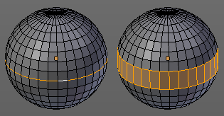
Edge Loops
This method works similar to the smart delete tool. It deletes the edge loop. But it selects the faces of the edge ring. And the Last operator offers you the option to split off face corners.

Last Operator Delete Edge Loop

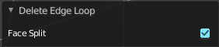
Face Split
Split off face corners to maintain surrounding geometry.

Dissolve
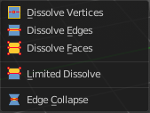
Dissolve operations removes for examples selected vertices, edges and faces. But they are not delete operations. They are union tools.
When you for example choose Delete vertices from the mesh menu, then the involved faces can get deleted too. When you choose Dissolve vertices, then the vertices gets removed, and the faces stays intact. The edges gets unioned.
Dissolve is a union operation.

Dissolve Vertices
Dissolve Vertices dissolves the selected Vertices.
Note that pressing DEL in Vertice select mode calls Dissolve Vertices already. It's the same operator. But you don't get the Last operator that way.

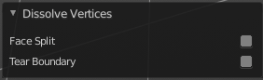
Last Operator Dissolve Vertices

Face Split
Split off Face corners to maintain surrounding geometry

Tear Boundary
Split off Face corners instead of merging faces.

Dissolve Edges
Dissolve Edges dissolves the selected Edges.
Note that pressing DEL in Edge select mode calls Dissolve Edges already. It's the same operator. But you don't get the Last operator that way.

Last Operator Dissolve Edges

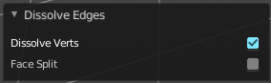
Dissolve Verts
When the dissolve operation leaves vertices behind, then this vertices will be dissolved too.

Face Split
Split off Face corners to maintain surrounding geometry

Dissolve Faces
Dissolve Faces removes the inlaying edges of the selected faces. This faces becomes one big N-Gon.

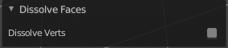
Last Operator Dissolve Faces

Dissolve Verts
When the dissolve operation leaves vertices behind, then this vertices will be dissolved too.

Limited Dissolve
Limited Dissolve dissolves the selected Edges and Vertices, limited by the surrounding geometry.

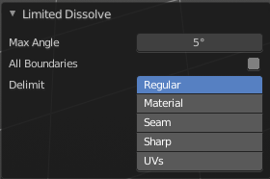
Last Operator Limited Dissolve

Max Angle
The limiting angle.

All Boundaries
All Boundaries dissolves in-between face boundaries.

Delimit
You can also delimit by other methods than normals.

Edge Collapse
Edge Collapse collapses the selected edges to a vertice at the center of the selection.

Mesh Select Mode

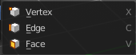
Mesh Select mode is a sub menu Set the current mesh select mode. Its functionality is equal to the mesh select mode buttons in the header. Just that you can't select more than one mode directly here.
This menu just exists to show and to edit the hotkeys. Not to work with it.

